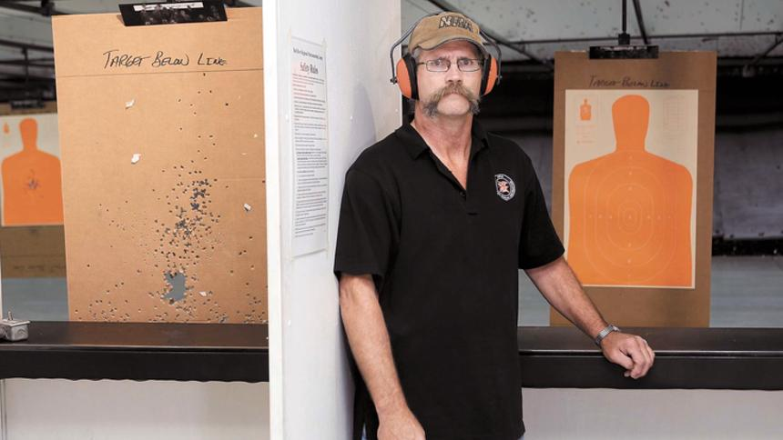
Craig Roe is a shooting instructor at Red River Regional Marksmanship Center in West Fargo. Dave Wallis / The Forum
It's My Job: Firearms instructor enjoys educating
By Josh Francis on Sep 28, 2014 at 4:31 p.m.
Email
West Fargo - With a surge in firearms purchases in the past few years, instructors like Craig Roe of Kindred, N.D., have an important role to play to make sure new gun owners know how to use guns and make them aware of the many regulating laws.
is an independent firearms instructor who teaches novice and experienced gun owners how to properly use firearms. His job extends to teaching about the laws in different states and components of firearms, like types of ammunition and choosing the right gun.
Roe, 58, has been around firearms almost his entire life. After his cabinet making business burned down in 2010, he decided it was time to move on. He spent 33 years as a cabinet maker and he has been a firearms instructor for three years. He is also training another firearms instructor, Dennis Jones, 46.
Roe teaches classes at the Red River Regional Marksmanship Center and at other facilities in the area. He has several instructor certifications from the National Rifle Association, which he is a lifetime member of. Roe and Jones are both range safety officers, as well.
Roe has also been a hunter education instructor for 15 years.
Why do people typically buy firearms?
Some of those reasons are definitely self-defense, I think across the nation self-defense is on an upswing.
I think a lot of people are interested in exercising their Second Amendment rights. They’ve been under attack a lot, especially in the last several years.
There was a huge upswing, especially in 2012 and through 2013; that was huge after the (presidential) election and the shooting in Connecticut, and I think people were worried about being able to exercise those rights.
Other reasons are just owning firearms in general. North Dakota especially has a long history with firearms ownership, there’s a lot of hunting in North Dakota.
I think people like the idea of owning firearms. They like to hunt, they like to shoot. A lot of people up here are just big into collecting firearms.
What are some important rules gun owners need to know that you advise them on?
There’s a lot of laws that I don’t think a lot of people realize to do with having a gun with them, or having one in the car, even transporting across state lines.
There are different rules in every single state, some are the same but when you’re traveling into another state you need to know the rules of that state because they can vary rather considerably. All the states stress very much knowing the laws of those states. A shooting instructor was killed in Arizona recently. What went wrong and what can people learn from incidents like that?
I always tell my students when they talk about firearms accidents, that there’s no such thing as a firearms accident. A firearm doesn’t go off by itself and if it goes off and somebody gets hurt and something has gone wrong with it, it’s almost always one of two things: Ignorance and lack of knowledge.
What is the most rewarding part of your job?
I like when I explain things to people who are completely unknowledgeable of what I’m talking about and they’ve learned something from the class.
What are some common misconceptions about shooting?
They’re not the nasty things that everyone who is unknowledgeable about guns seems to think. A lot of what you hear in the media today, I believe comes from people who aren’t knowledgeable about guns.
People seem to think that you can just walk into a store and buy a gun, that’s not true at all. I sell guns myself ... a background check is done on you. To get any of the permits to carry a gun, background checks are done on you.
You can still buy guns from private owners without a background check but if you’re buying or selling a gun to someone who’s not legal to possess a gun you are committing a felony.

Jamestown Regional Medical Center

Hanson-Runsvold Funeral Home

Jamestown Regional Medical Center

Altru Health
Achieve Your Goal of Helping Others when you start your career wtih Altru!Nursing,Professional,more!
ger Funeral Home
anson-Runsvold Funeral Home
Have the "Talk of a Lifetime" www.hansonrunsvold.com
Jamestown Regional Medical Center
Make a difference in our community. JRMC has an excellent opportunity for an HIS MANAGER!
n-Runsvold Funeral Home
Have the "Talk of a Lifetime" www.hansonrunsvold.com

